Iosco Conservation District
2017-2018 Meeting Schedule
190 M-55
Tawas City, MI 48763
www.ioscoconservation.org

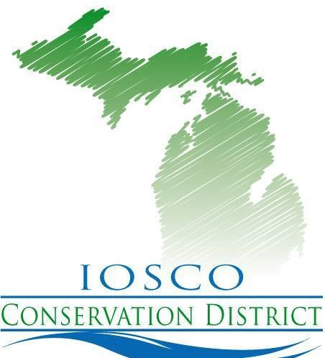
All meetings are open to the public.
Meetings are at 4:00 p.m. at the Iosco Conservation District office
on the Second Monday of every month
unless otherwise noted.

October 8, 2018
November 12, 2018
December 10, 2018
January 7, 2019
February 11, 2019
March 11, 2019
April 8, 2019
May 13, 2019
June 10, 2019
July 8, 2019
August 12, 2019
September 9, 2019

Upon request, the District’s Board of Directors shall make reasonable accommodation for a person with disabilities to be able to participate in these meetings.

Privacy Act Statement
The following statements are made in accordance with the Privacy Act of 1974 (5 U.S.C 522a). Furnishing this information is voluntary; however failure to furnish correct, complete information will result in the withholding or withdrawal of such technical or financial assistance. The information may be furnished to other USDA agencies, the Internal Revenue Service, The Department of Justice or other state or federal law enforcement agencies, or in response to orders of a court, magistrate, or administrative tribunal.
Non-Discrimination Statement
In accordance with federal civil rights law and U.S. Department of Agriculture (USDA) civil rights regulations and policies, the USDA, its Agencies, offices, and employees, and institutions participating in or administering USDA programs are prohibited from discriminating based on race, color, national origin, religion, sex, gender identity (including gender expression), sexual orientation, disability, age, marital status, income derived from a public assistance program, political beliefs, or reprisal or retaliation for prior civil rights activity, in any program or activity conducted or funded by USDA (not all bases apply to all programs). Remedies and complaint filing deadlines vary by program or incident. Persons with disabilities who require alternative means of communication for program information (e.g., Braille, large print, audiotape, American Sign Language, etc.) should contact the responsible Agency or USDA's TARGET Center at (202) 720-2600 (voice and TTY) or contact UDA though the Federal Relay Service at (800) 877-8339. Additionally, program information may be made available in languages other than English.
USDA and Iosco Conservation District are equal opportunity providers, employers and lenders.

