Finding Out About Fall Mushrooms
By Sister Marie Kopin, C.PP.S., October 14th , 2017
Iosco County Conservation District, E. Tawas, MI and the Michigan Mushroom Hunters Club

MOTTO: Mycologists Have More FUN-gi
- There are roughly 3,000 species of mushrooms known to grow in Michigan and 100,000 have been Identified world-wide. There may be over a billion not yet identified.
- Approximately 250 species are poisonous with 12-15 species deadly poisonous, and the rest ranging from serious GI tract symptoms to minor GI tract problems. Approximately 250 species are edible ranging from barely palatable to exquisite. All of the rest fall into categories like too woody or leathery to eat, too bitter, too acrid (hot and/or peppery).
Five Dangerous and Poisonous Spring,Summer & Fall mushrooms of the North Central area of Michigan’s Lower Peninsula

  - Death Angel: Amanita bisporigera or Amanita verna: Deadly
  - Galerina autumnalis or marginata: Deadly
  - Omphalotus olearius Jack-O-Lantern mushroom, orange and glows in dark, toxic, resembles honey mushrooms
  - Chlorophyllum moylbdites: the green-spored Lepiota: Looks like edible parasol mushrooms, most often reported toxic mushroom, dehydrates, 24 hour misery
  - Gyrometra: Beefsteak, false morel (spring mushroom): Long term toxic effects in some, cancer, some species can be deadly to some.

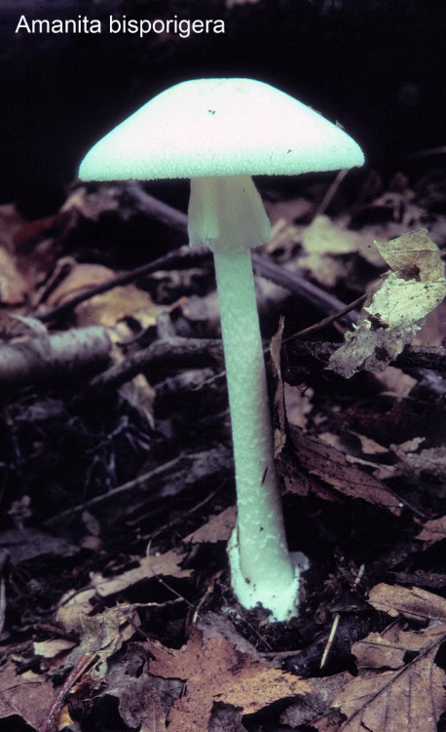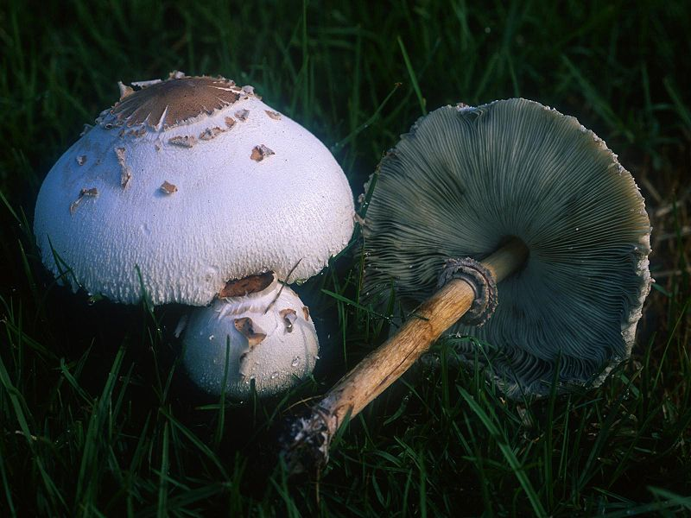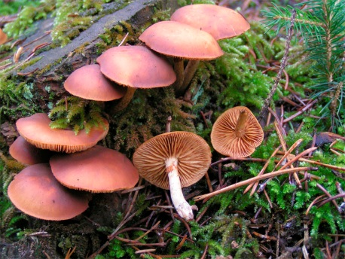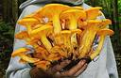

Death Angel Green Spored Parasol Galerina Jack-O-Lantern

Resources and References list
Some Mushroom Websites
Midwest American Mycology Information (MAMI): http://www.midwestmycology.org/ Website for obtaining a certificate to inspect Mushrooms in Michigan by Chris Wright, Executive Director of the project. Good photos and descriptions of 20 edible mushrooms from Michigan, and 3 very toxic mushrooms
Michigan Mushroom Hunters Club: Join the Michigan Mushroom Hunters Club, $15 per family or individual, includes members only forays, Fall Fungus Fest, Lewiston Hunts, SE MI and Central MI hunts, UP hunts. Go to www.michiganmushroomhunters.org for membership info and much more. For MI mushrooms check out the “Mushrooms of the month” for many years of Michigan Species of Mushrooms written by past MMHC President, Phil Tedeschi.
North American Mycological Association, NAMA, http://namyco.org , see http://namyco.org/toxicology/index.html for details on poisonings and what to do. We have 6 people in Michigan ready and available by phone for consultations listed on the website. http://www.michiganmorels.com/funtalk/showthread.php?t=7617 has photos of MI edibles http://www.easygrowmushrooms.com/composter.shtml by Chris Wright, grow “Composter Mushrooms” in your Garden
Free Mushroom App: Roger Philips. More advanced App info at: http://www.rogersmushrooms.com/apps.asp Also Audubon Guide App
www.mushroomexpert.com , great on-line resource to key out species with photos by Michael Kuo
www.mushroomobserver.com Place to list and ID your fungal finds with others
Free Mushroom App: Roger Philips, also Audubon App by Gary Lincoff
Books & Other Resources
The Audubon Field Guide to North American Mushrooms, Gary H. Lincoff, & Mushroom App
Edible Wild Mushrooms of North America, David Fischer and Alan Bessette
Field Guide to Common Macrofungi in Easter Forests and their Ecosystem Functions, Can also download this. Free Booklet from USDA: National Forest Service: order at http://www.nrs.fs.fed.us/pubs/order/38089
Mushrooms of the Northeast, Teresa Marrone and Walt Sturgeon, 2016
The Mushroom Hunter's Field Guide: Alexander H Smith, Nancy Smith Weber
USA Poison Control Center: 1-800-222-1222. This number connects with any local center in any state in the USA.
Contact Sister Marie Kopin, C.PP.S. for questions: mkopin@winntel.net, (989)-772-9453. You Tube: Check out many informative videos on mushrooms
What to bring/send for Identification
1. All the mushroom including the base, record what it grows on/near.
2. Spore Print (put gills on dull side of a sheet of aluminum foil or while/black paper overnight or 3-6 hours), report color
3. Photos with different views, top, under cap/top, sideways, bottom, stem, slice stem, slice cap, different stages of the mushroom
4. Report smell, taste, and surfaces
5. Use a ruler or something to identify size in photos
What to take on a Mushroom Hunt/Foray
- Go to https://www.michiganmushroomhunters.org/for-beginners www.michiganmushroomhunters.org and check in beginner’s section
- Whistle to signal finds (2 x’s) and “I need Help, Emergency” (3 x’s)
- Bug spray and tic prevention
- Dress for the Occasion, NOT for the Beach!
- Cell Phone and emergency numbers
- Picking basket, paper bags (no plastic) and/or waxed paper for saving specimens
- Harvesting tool/knife
- If saving specimens for ID take all parts; if collecting to eat, clean all with a brush before putting in a bag/basket
- Check for a more detailed list at https://www.michiganmushroomhunters.org/
- Check for a more detailed list at www.michiganmushroomhunters.org

Favorite kinds of Fall Mushrooms reported Edible to most People, known in the Central Part of Michigan’s Lower Peninsula
- Angel Wings: Pleurotus porrigens, on logs, some eat
- Black Trumpets: Craterellus fallax & Craterellus cornucopioides
- Blewits: Lepista nuda: usually under pines
- Bolete: Boletus edulis (King), and many others, tubes underneath
- Boletus chromapes, “Bi-Color” has 3 colors with yellow lower stem
- Brickcaps and Capnoides: Naematoloma sublateritium, and Hypholoma capnoides, brick red tops, blackish purple-green underneath
- Chanterelles, golden and red, Chicken Fat, yellow Suillus: Suillus americanus
- Chicken of the woods: Laetiporus sulphureus, usually up high on trees; Laetiporus cincinnatus, pinkish color at base of tree on roots on ground
- Clubfoot: Clitocybe clavipes, under pines, conical, ‘foot’, brownish, small
- Cup Fungi: Woodears, Auricularia auricula-judae; red cups
- Deer or Fawn mushroom: Pluteus cervinus, soft, on wood
- Dryad saddles or Pheasant backs: Polyporus squamosus, big beige
- Entoloma abortivum, white spongy parasitic on wood
- Hedge Hog, Sweet Tooth: Hydnum repandum
- Hen of the woods: Grifola frondosa, at base of oaks
- Honey/ Stump mushrooms: Yellow Honey, Armillaria mellea; Brown Honey, Arillaria gallica& other species on or near stumps and pieces of woods
- Hygrophorus russula: white with Pinkish/reddish sort of spots on top
- Lions Mane or Bears Tooth: Hericium erinaceus or coralloides, like waterfalls, white, on wood
- Lobster Mushroom: Hypomyces lactifluorum, reddish parasite on mushrooms
- Man on horseback: Tricholoma flavovirens, under pine needles pushing up pine needles and dirt
- Meadows or Pink Bottoms: Agaricus campestris
- Mouse ears (MI name): Tricholoma myomyces , gray and small, thick stems
- Orange-Latex Milky, Saffron Milk-Cap : Lactarius deliciosus , milks with reddish color
- Oyster mushroom: Pleurotus ostreatus, white overlapping on wood
- Oyster "Elm mushroom" - (Hypsizygus ulmarius)
- Puff Balls, False: Enteridium lycoperdon
- Puff Balls: Giganteus, medium sized, small: Lycoperdon pyriforme and perlatum
- Purple perlatum Laccaria: Laccaria ochropurpurea
- Red Cracked Bolete: Boletus chrysenteron
- Red-capped scaber stalk: Leccinum aurantiacum
- Reddening Lepiota: Lepiota americana, stains pink to red, spores white
- Russula: many colors and varieties, all gills ‘crumble’ and ‘flake’, red in MI are peppery; Green Quilted Russula, Russula virescens
- Shaggy Manes: Coprinus comatus, like broom stick handles, drips black
- Shaggy Parasol: Macrolepiota rachodes ; Macrolepiota rhacodes
- Short-stalked Suillus: Suillus brevipes, under pines; Suillus pictus; Suillus Americanus, chicken Fat mushroom
- Store Mushroom “look-a-likes:” Agaricus bisporus (store mushroom), Horse mushroom, arvensis; pink bottoms or meadow mushrooms campestris
- Truffles: under white pine in MI, very small, must dig
- Velvet Foot: Flammulina velutipes, likes cold, dark colored furry stalks
- Volemus; Lactarius volemus, Orangish Milk Caps

The Ten Commandments of Eating Wild Mushrooms
by Moses Mycophagist

1 Never eat a mushroom unless it is positively identified as edible. Mistakes can result in toxic reactions ranging from mild gastric distress to hospitalization and death. When in doubt throw it out!

2 Eat only fresh mushrooms that are free from infestation by insects or larva. Mushrooms can spoil, and eating any spoiled food can cause food poisoning and adverse reactions.

3 Cook all mushrooms thoroughly. Some mushrooms contain toxins or gastrointestinal irritants that are rendered harmless only by cooking.

4 Eat mushrooms only in moderate quantities. Mushrooms are not easily digested; over-eating them is an easy way to get sick.

5 When trying a mushroom for the first time, eat only a small portion, and don't try any new kinds for 48 hours. As with many foods, some people are sensitive or allergic to mushrooms commonly eaten by others. Individuals with known food allergies or sensitivities should be extra careful when trying new mushrooms, especially those known to present problems for some individuals.

6 Don't pick mushrooms from contaminated habitats. These include chemically treated lawns, ornamental trees, power line right-of-ways, railroad right-of-ways, highways, and areas close to landfills, toxic waste areas, crop fields, and firebreaks. Contaminants may accumulate in wild mushrooms.

7 Never assume that a wild mushroom that you find in another country is the same edible species you know from North America, or vice versa. Many serious cases of mushroom poisoning occur when vacationers and immigrants gather and eat dangerous look-alike species not found in their native lands.

8 Be conservative about feeding wild mushrooms to children, the elderly, and the infirm. Avoid edible species known to cause adverse - reactions in some people. Limit portion sizes for children, the elderly, and the sick because they are generally more susceptible to toxins than other people.

9 When trying a wild mushroom for the first time, save a few intact, uncooked specimens in the refrigerator for 48 hours. If one develops an illness or reaction within two days after trying an unfamiliar mushroom, a physician may need an uncooked specimen for identification to rule out the mushroom as a culprit.

10 Examine every specimen in every collection to avoid inadvertent mixing of different species.
From CVMS Spore Print, 1998, Connecticut Westchester Mycological Association (COMA) Spores Illustrated, spring, 200

